SUMMER TRAINING REPORT (14 PT.)

ON

# [Sociography]

SUBMITTED IN PARTIAL FULFILLMENT OF THE REQUIREMENT FOR THE AWARD

OF THE DEGREE OF (12pt.)

**BACHELOR OF ENGINEERING**(14 pt.)

(Computer Science & Engineering)(14pt.)

MAY-JUNE,2021(14 pt.)

**SUBMITTED BY:**

NAME(S) : **Vadik Amar**

UNIVERSITY UID : **20BCS2872**

(12pt.)

**Mentor Signature**

**Er. Priyanka Rawat and Er. Palwinder Kaur Mangat**

DEPARTMENT OF COMPUTER SCIENCE &ENGINEERING (12pt.)

CHANDIGARH UNIVERSITY GHARUAN, MOHALI(14pt.)

**B.ETRAINING REPORT GUIDELINES**

1. The report shall be computer typed (English- British, Font -Times Roman, Size-12 point, Double spacing between lines) and printed on A4 size paper.
2. The report shall be spiral bound. The name of the candidate, degree, month of training, college name shall be printed on the title page [refer sample sheet (title page/front page)].
3. The report shall be typed on one side only with double space with a margin 3.5 cm on the left, 2.5 cm on the top, and 1.25 cm on the right and at bottom.
4. In the report, the title page [Refer sample sheet (title Page/front page)] should be given first then theCertificate by Course Website/Company/Industry/Institute and then candidate’s declaration, followed by an abstract of the report (notexceeding one page). This should be followed by the acknowledgment, list of figures/list of tables, notations/nomenclature, and then contents with page nos.
5. The diagrams should be printed on a light/white background, Tabular matter should be clearly arranged and the font of the Tabular matter should be Font -Times Roman, Size-10 point, Single spacing between lines. Decimal point may be indicated by full stop(.). The caption for figure must be given at the BOTTOM(center aligned) of the figure and Caption for the Table must be given at the TOP(center aligned) of the Table. The font for the captions should be Times Roman, *Italics*, Size-10 point.
6. The font for the chapter titles should be Times Roman, Bold, Capital, Size-16 point and center aligned. The font for the Headings should be Times Roman, Bold, and Size-14 point. The font for the sub-headings should be Times Roman, Bold, and Size-12 point.
7. Equations should be numbered as 1.1, 1.2, 1.3 etc in chapter 1. Similarly as 2.1, 2.2, 2.3 etc in chapter 2 and so on.
8. Figures should be numbered as Figure1.1, Figure 1.2, Figure1.3 etc in chapter 1. Similarly as Figure 2.1, Figure 2.2, Figure 2.3 etc in chapter 2 and so on.
9. Tables should be numbered as Table 1.1, Table 1.2, Table1.3 etc in chapter 1. Similarly as Table 2.1, Table 2.2, Table 2.3 etc in chapter 2 and so on.
10. Conclusions and future scope each must not exceed more than one page.
11. The graphs (optional) should be combined for the same parameters for proper comparison. Single graph should be avoided as far as possible.
12. The training report must consist of following chapters:

[Chapter-1] INTRODUCTION

[Chapter-2] TRAINING WORK UNDERTAKEN

[Chapter-3] RESULTS AND DISCUSSIONS

[Chapter-4] CONCLUSION AND FUTURE SCOPE

1. References (For style of references follow the instructions attached)
2. Appendix (Any additional information regarding training,(If any)e.g. program, is supposed to be included in appendix )
3. Paste a CD containing the soft copy of Report (in Docx and PDF), Implementation &Reference papers and other material (if any,) related to the work, on the inner side of back hard cover.

|  |
| --- |
|  |

**CHANDIGARH UNIVERSITY,GHARUAN,MOHALI**

**CANDIDATE'S DECLARATION**

I “**Vadik Amar**” hereby declare that I have undertaken Summer Training and developed project titled **Sociography** during a period from **14 June 2021** to **08 July 2021** in partial fulfillment of requirements for the award of degree of B.E(COMPUTER SCIENCE & ENGINEERING) at CHANDIGARH UNIVERSITY GHARUAN, MOHALI. The work which is being presented in the training report submitted to Department of Computer Science & Engineering at CHANDIGARH UNIVERSITY GHARUAN, MOHALI is an authentic record of training work.

Vadik Amar

Signature of the Student

The training Viva–Voce Examination of__________________ has been held on ____________ and accepted.

 Signature of Internal Examiner Signature of External Examiner

**CERTIFICATE**

This is to certify that the work embodied in this project entitled “**Sociography**” has been submitted by “**Vadik Amar**” with UID – “**20BCS2872**” of the 3th Semester for the partial fulfillment of the requirement for the degree of “**Bachelor of Engineering in Computer Science& Engineering**” discipline in “**Chandigarh University**” during the academic session June-July 2021 is a record of bonafide piece of work, carried out by each student under my supervision and guidance in the “Department of Computer Science & Engineering”, Chandigarh University.

**Approved and guided by: -**

Project Mentor and Teacher: **Er. Priyanka Rawat and Er. Palwinder Kaur Mangat**

**ACKNOWLEDGEMENT**

* First of all, I would like to appreciate to thank the **Almighty** for bestowing his blessings upon us and over the successful completion of my project, and also keeping me healthy throughout.
* Secondly, I would like to thank and express our heartiest gratitude towards our project mentors, **Er. Priyanka Rawat and Er. Palwinder Kaur Mangat** helped and guided me at each and every step in completing my project.
* Without their guidance, I shall not have succeeded in our project successfully.

Finally, I would like to thank our institution, i.e. **“Chandigarh University”** for giving me such fortunate opportunity to showcase my talent through this project and I have gained a lot of knowledge about database and web development throughout the making of this project.

**TABLE OF CONTENTS**

DECLARATION………………………………………………………………………………….i

CERTIFICATE……………………………………………………………………………. ii

Acknowledgement …………………………………………………………………………………... iii

1. Introduction
2. TECHNOLOGY USED
3. SOFTWARE USED
4. Project Design
   1. Login page
   2. Home
   3. User’s Profile
5. Verification
   1. Database Entries
6. Applications
7. Conclusion

Bibliography…………………………………………………………………………………... iv

**INTRODUCTION**

**ABOUT Sociography:**

**Sociography** is a social networking web service designed with the help of front end- html, css and javascript and back end- sql, php. The sql and php will connect to a database to keep the records of the systems. Html is used to give structure, css is used to style and to decorate, and javascript is for functioning of website.

This web service provides an interface with which the users (professionals photographs) can access, upload their best clicks and being appreciated by other photographers for their work. Others can give like to photos for appreciation. This system will also help people other than photographs to contact photographs via email address. With this web service, it will be much easier and beneficial for both the photographers and non-photographs to make contact.

There different tabs for every type of photography like wildlife, architectural etc. to make it easy for users to find pictures according their preferences.

With the help of this web service, in future I am looking to add rating system which will make it more easy for the user to contact to best photographer if they need.

**TECHNOLOGY USED**

**HTML:** Hypertext Markup Language (HTML) is the standard [markup language](https://en.wikipedia.org/wiki/Markup_language) for documents designed to be displayed in a [web browser](https://en.wikipedia.org/wiki/Web_browser). It can be assisted by technologies such as [Cascading Style Sheets](https://en.wikipedia.org/wiki/Cascading_Style_Sheets) (CSS) and [scripting languages](https://en.wikipedia.org/wiki/Scripting_language) such as [JavaScript](https://en.wikipedia.org/wiki/JavaScript).

**Javascript:** **JavaScript** often abbreviated as **JS**, is a [programming language](https://en.wikipedia.org/wiki/Programming_language) that conforms to the [ECMAScript](https://en.wikipedia.org/wiki/ECMAScript) specification. JavaScript is [high-level](https://en.wikipedia.org/wiki/High-level_programming_language), often [just-in-time compiled](https://en.wikipedia.org/wiki/Just-in-time_compilation), and [multi-paradigm](https://en.wikipedia.org/wiki/Programming_paradigm). It has [curly-bracket syntax](https://en.wikipedia.org/wiki/List_of_programming_languages_by_type#Curly-bracket_languages), [dynamic typing](https://en.wikipedia.org/wiki/Dynamic_typing), [prototype-based](https://en.wikipedia.org/wiki/Prototype-based_programming) [object-orientation](https://en.wikipedia.org/wiki/Object-oriented_programming), and [first-class functions](https://en.wikipedia.org/wiki/First-class_function).

**Css: Cascading Style Sheets** (**CSS**) is a [style sheet language](https://en.wikipedia.org/wiki/Style_sheet_language) used for describing the [presentation](https://en.wikipedia.org/wiki/Presentation_semantics) of a document written in a [markup language](https://en.wikipedia.org/wiki/Markup_language) such as [HTML](https://en.wikipedia.org/wiki/HTML). CSS is a cornerstone technology of the [World Wide Web](https://en.wikipedia.org/wiki/World_Wide_Web), alongside HTML and [JavaScript](https://en.wikipedia.org/wiki/JavaScript).

**Php: PHP** is a [general-purpose](https://en.wikipedia.org/wiki/General-purpose_programming_language) [scripting language](https://en.wikipedia.org/wiki/Scripting_language) especially suited to [web development](https://en.wikipedia.org/wiki/Web_development). It was originally created by Danish-Canadian [programmer](https://en.wikipedia.org/wiki/Programmer) [Rasmus Lerdorf](https://en.wikipedia.org/wiki/Rasmus_Lerdorf) in 1994. The PHP [reference implementation](https://en.wikipedia.org/wiki/Reference_implementation) is now produced by The PHP Group. PHP originally stood for *Personal Home Page*, but it now stands for the [recursive initialism](https://en.wikipedia.org/wiki/Recursive_initialism) *PHP: Hypertext Preprocessor*

**MySQL Database:** Oracle MySQL Database Service is a fully managed database service that lets developers quickly develop and deploy secure, cloud native applications using the world’s most popular open source database. MySQL Database Service is the only MySQL cloud service with an integrated, high-performance analytics engine—HeatWave—that enables customers to run sophisticated analytics directly against their operational MySQL databases, eliminating the need for complex, time-consuming, and expensive data movement and integration with a separate analytics database.

**SOFTWARE USED**

**VS Code:** Visual Studio Code is a [source-code editor](https://en.wikipedia.org/wiki/Source-code_editor) made by [Microsoft](https://en.wikipedia.org/wiki/Microsoft) for [Windows](https://en.wikipedia.org/wiki/Windows), [Linux](https://en.wikipedia.org/wiki/Linux) and [macOS](https://en.wikipedia.org/wiki/MacOS). Features include support for [debugging](https://en.wikipedia.org/wiki/Debugging), [syntax highlighting](https://en.wikipedia.org/wiki/Syntax_highlighting), [intelligent code completion](https://en.wikipedia.org/wiki/Intelligent_code_completion), [snippets](https://en.wikipedia.org/wiki/Snippet_(programming)), [code refactoring](https://en.wikipedia.org/wiki/Code_refactoring), and embedded [Git](https://en.wikipedia.org/wiki/Git). Users can change the [theme](https://en.wikipedia.org/wiki/Theme_(computing)), [keyboard shortcuts](https://en.wikipedia.org/wiki/Keyboard_shortcut), preferences, and install [extensions](https://en.wikipedia.org/wiki/Plug-in_(computing)) that add additional functionality.

Microsoft has released most of Visual Studio Code's [source code](https://en.wikipedia.org/wiki/Source_code) on the microsoft/vscode repository of [GitHub](https://en.wikipedia.org/wiki/GitHub) using the "Code – OSS" name, under the permissive [MIT License](https://en.wikipedia.org/wiki/MIT_License), while the releases by Microsoft are proprietary [freeware](https://en.wikipedia.org/wiki/Freeware).

**Mozilla Firefox :** Firefox Browser, also known as Mozilla Firefox or simply Firefox, is a [free and open-source](https://en.wikipedia.org/wiki/Free_and_open-source_software) [web browser](https://en.wikipedia.org/wiki/Web_browser) developed by the [Mozilla Foundation](https://en.wikipedia.org/wiki/Mozilla_Foundation) and its subsidiary, the [Mozilla Corporation](https://en.wikipedia.org/wiki/Mozilla_Corporation). Firefox uses the [Gecko](https://en.wikipedia.org/wiki/Gecko_(software)) [rendering engine](https://en.wikipedia.org/wiki/Browser_engine) to display web pages. In 2017, Firefox began incorporating new technology under the code name [Quantum](https://en.wikipedia.org/wiki/Quantum_(Mozilla)) to promote [parallelism](https://en.wikipedia.org/wiki/Parallel_computing) and a more intuitive [user interface](https://en.wikipedia.org/wiki/User_interface). Firefox is available for [Windows 7](https://en.wikipedia.org/wiki/Windows_7) or [Windows 10](https://en.wikipedia.org/wiki/Windows_10), [macOS](https://en.wikipedia.org/wiki/MacOS), and [Linux](https://en.wikipedia.org/wiki/Linux). [Its unofficial ports](https://en.wikipedia.org/wiki/Firefox#Unofficial_ports) are available for various [Unix](https://en.wikipedia.org/wiki/Unix) and [Unix-like](https://en.wikipedia.org/wiki/Unix-like) operating systems including [FreeBSD](https://en.wikipedia.org/wiki/FreeBSD), [OpenBSD](https://en.wikipedia.org/wiki/OpenBSD), [NetBSD](https://en.wikipedia.org/wiki/NetBSD), [illumos](https://en.wikipedia.org/wiki/Illumos), and [Solaris Unix](https://en.wikipedia.org/wiki/Solaris_Unix). Firefox is also available for [Android](https://en.wikipedia.org/wiki/Firefox_for_Android) and [iOS](https://en.wikipedia.org/wiki/Firefox_for_iOS). However, the iOS version uses the [WebKit](https://en.wikipedia.org/wiki/WebKit) layout engine instead of Gecko due to platform requirements, as with all other iOS web browsers. An optimized version of Firefox is also available on the [Amazon Fire TV](https://en.wikipedia.org/wiki/Amazon_Fire_TV), as one of the two main browsers available with [Amazon's Silk](https://en.wikipedia.org/wiki/Amazon_Silk) Browser.

**Xampp : XAMPP** is a [free and open-source](https://en.wikipedia.org/wiki/Free_and_open-source) [cross-platform](https://en.wikipedia.org/wiki/Cross-platform) [web server](https://en.wikipedia.org/wiki/Web_server) [solution stack](https://en.wikipedia.org/wiki/Solution_stack) package developed by Apache Friends, consisting mainly of the [Apache HTTP Server](https://en.wikipedia.org/wiki/Apache_HTTP_Server), [MariaDB](https://en.wikipedia.org/wiki/MariaDB) [database](https://en.wikipedia.org/wiki/Database), and [interpreters](https://en.wikipedia.org/wiki/Interpreter_(computing)) for scripts written in the [PHP](https://en.wikipedia.org/wiki/PHP) and [Perl](https://en.wikipedia.org/wiki/Perl) [programming languages](https://en.wikipedia.org/wiki/Programming_language). Since most actual web server deployments use the same components as XAMPP, it makes transitioning from a local test server to a live server possible.

**Project Design**

1. Login Page

* Username
* Password
* Sign in
* Sign up

2. Home page

* Search button
* Tabs for different types of photography( Wildlife , Architectural etc.)
* Art of photography
* Popular user
* Contact form
* FAQ, Privacy policy
* Social media handle

3. Profile of user

* Home button
* User’s username , description , and profile photo
* Follow button
* Photos uploaded by users

**1. Login Page, Sign up page and contact form**

This is the very first page that opens up on the local host server from any web browser when we run this web application from the IDE. Here, the user gets to see four elements namely, Username, Password, Sign-in, and Sign-up.

Now, if the user is new to the web service, then he/she shall have to first register himself/herself by entering the required details and saving his/her account details to the connected database (which happens automatically at the back-end on just clicking the Save User Details button). After this the user is redirected to the login page where he/she has to enter their username and password and sign-in to access their account.

If the user has an existing account, then he/she just simply need to enter their username and password and sign-in to access their account.

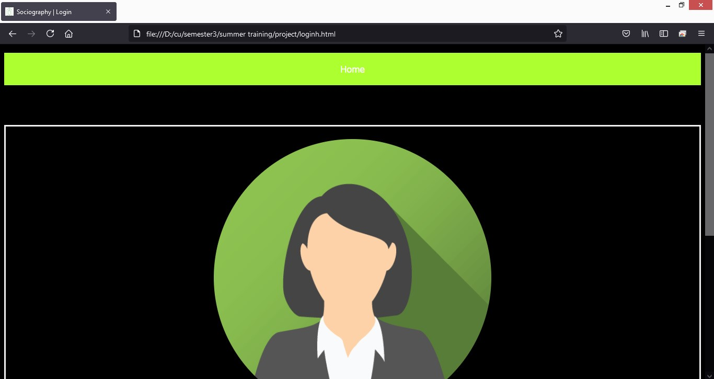

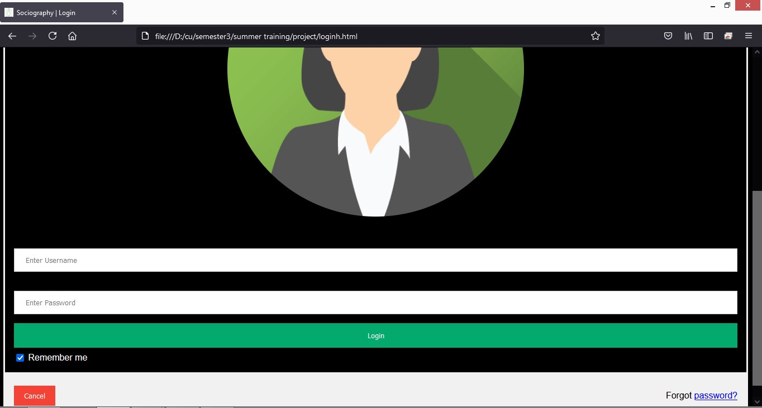

**Sign up page**

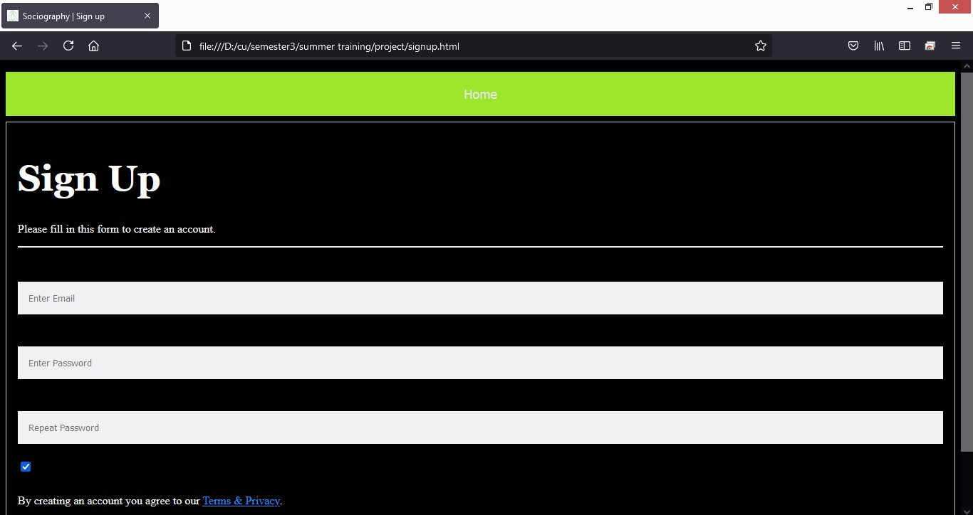

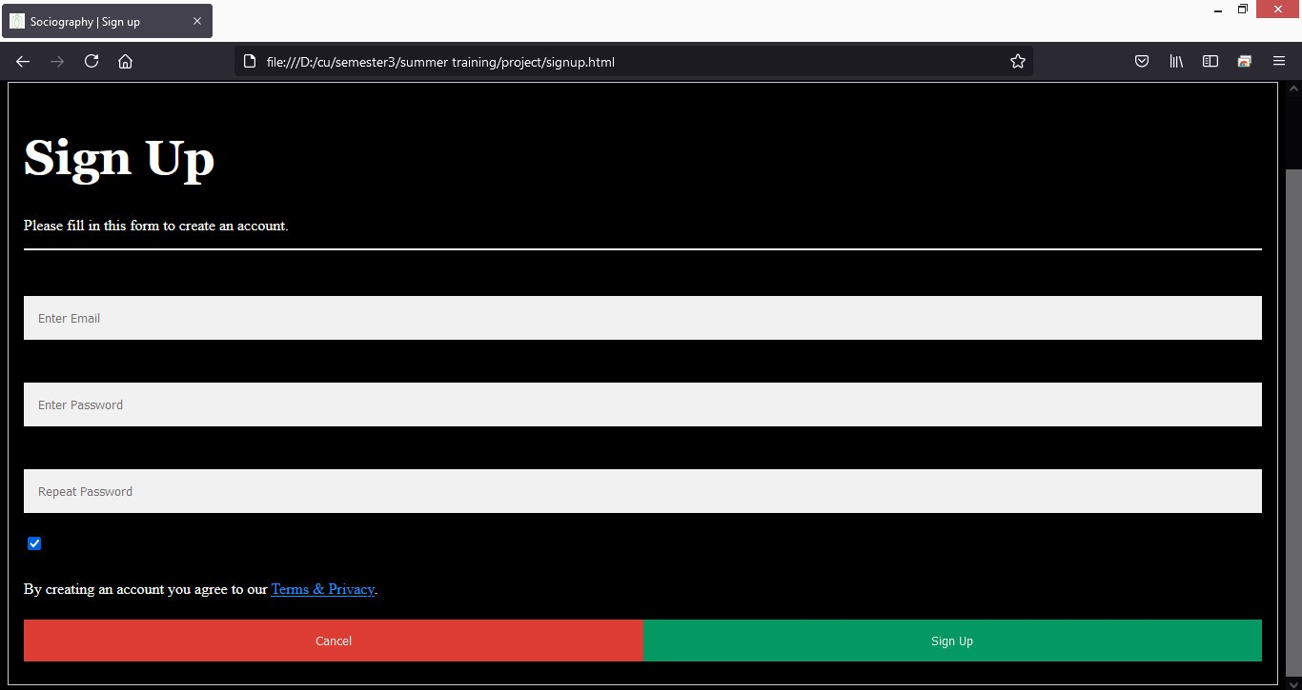

**Contact form**

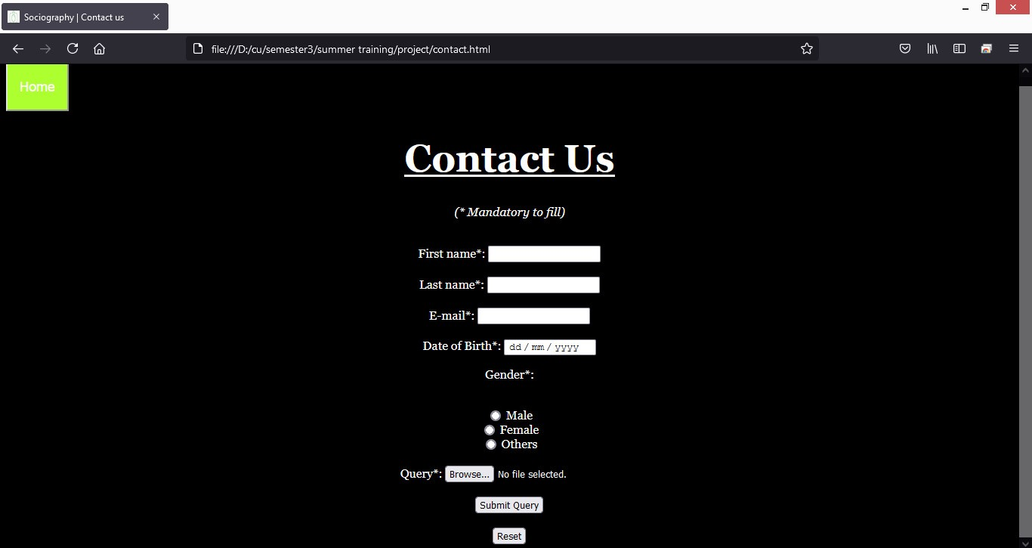

**2. Home Page**

User who can be a customer/ a photographer, can only access the five elements mentioned in the Home Page namely, Search button, Tabs for different types of photography( Wildlife , Architectural etc.), Art of photography ,Popular user, Contact form, FAQ, Privacy policy and Social media handle.



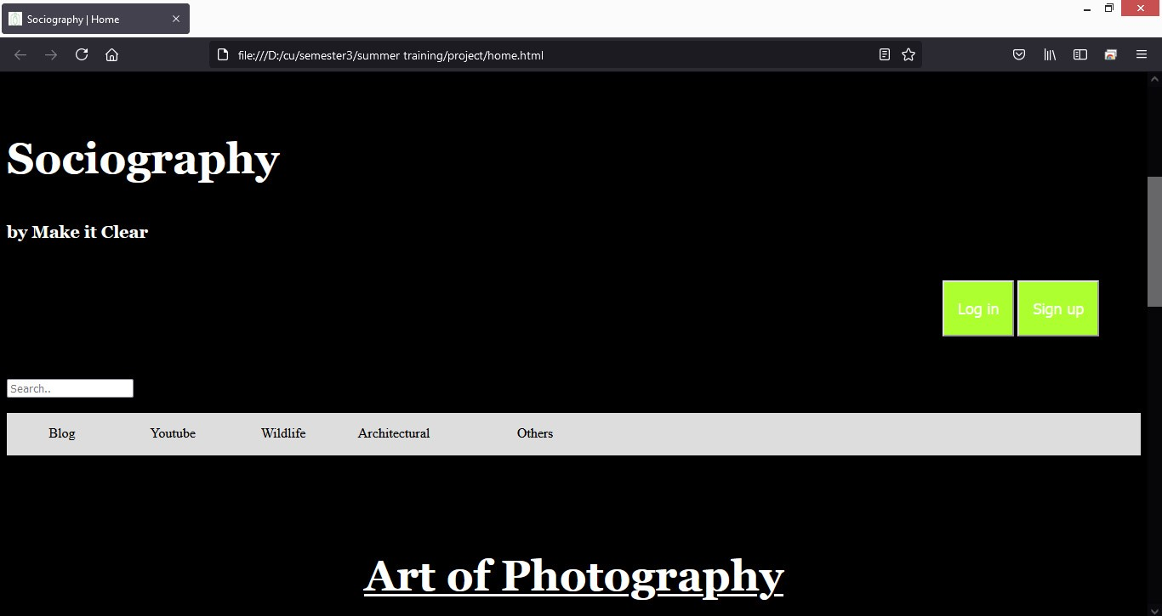

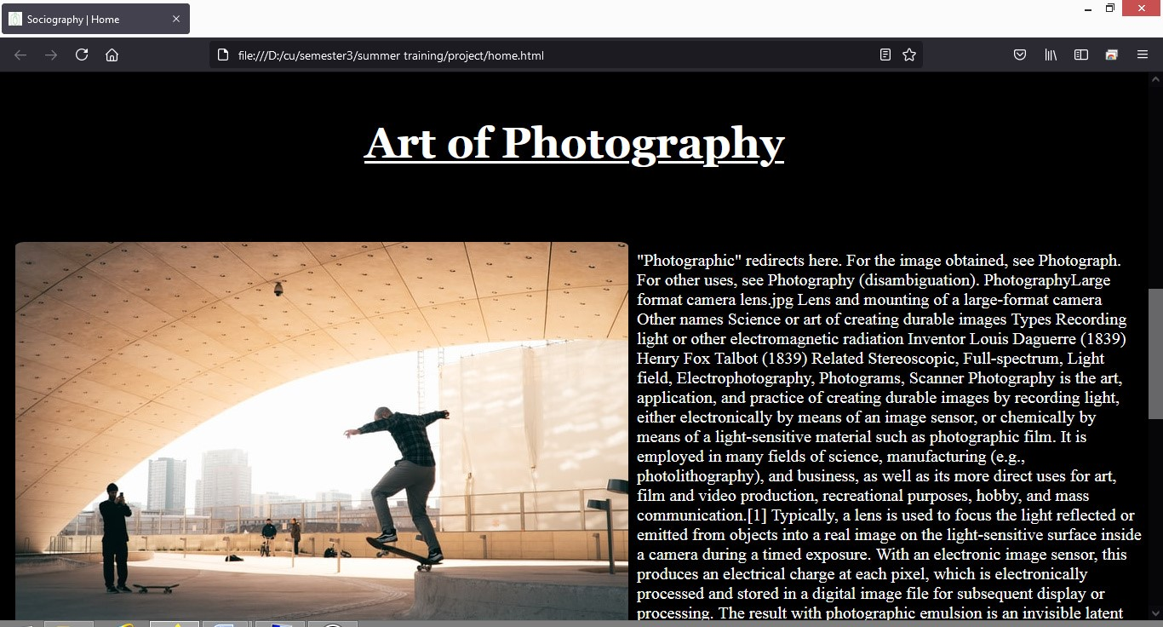

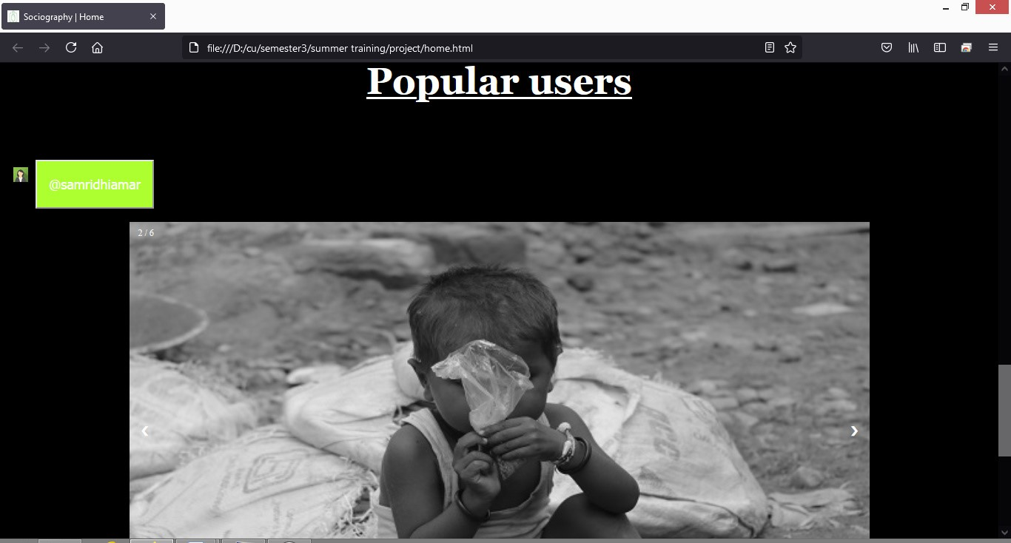

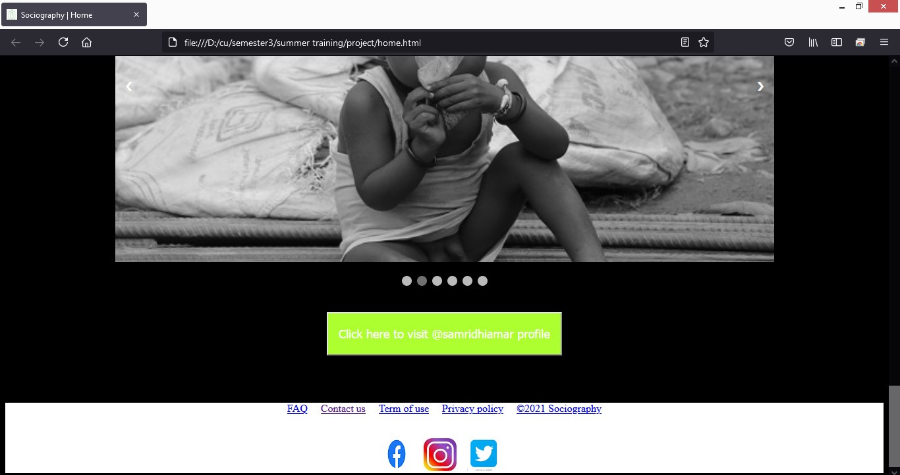

**3. Profile of user**

Profile of user consist of elements like Home button, User’s username , description , and profile photo, Follow button and Photos uploaded by users.

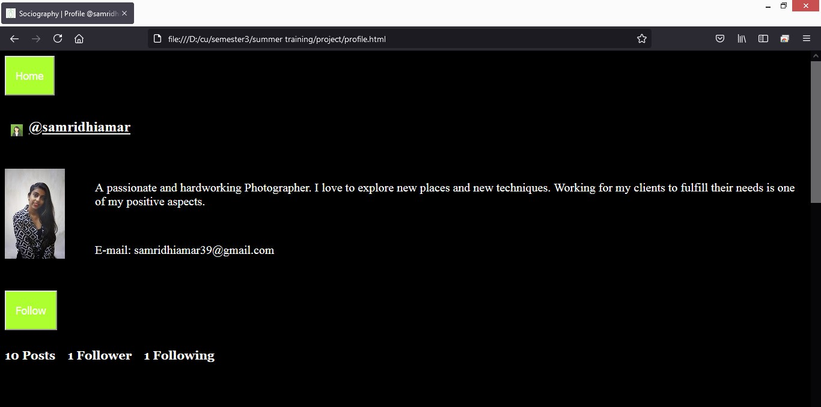

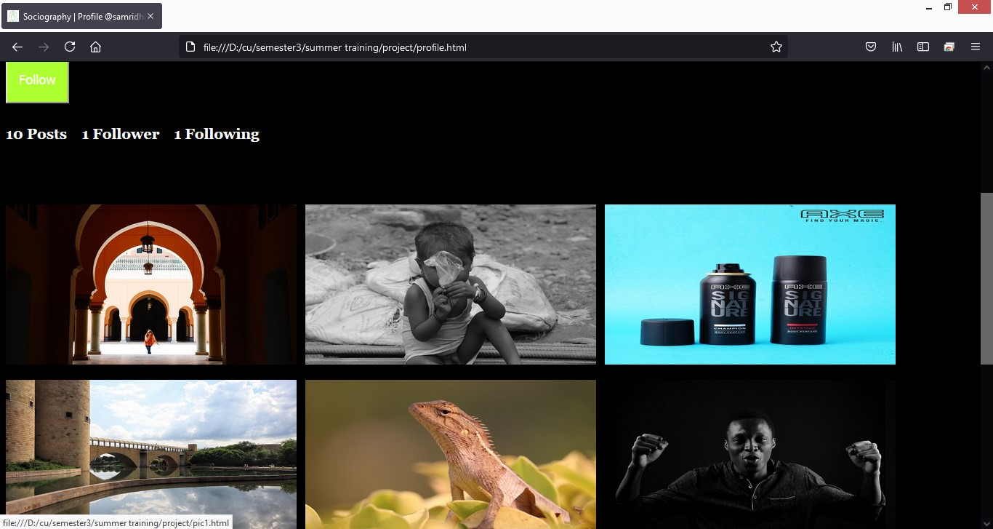

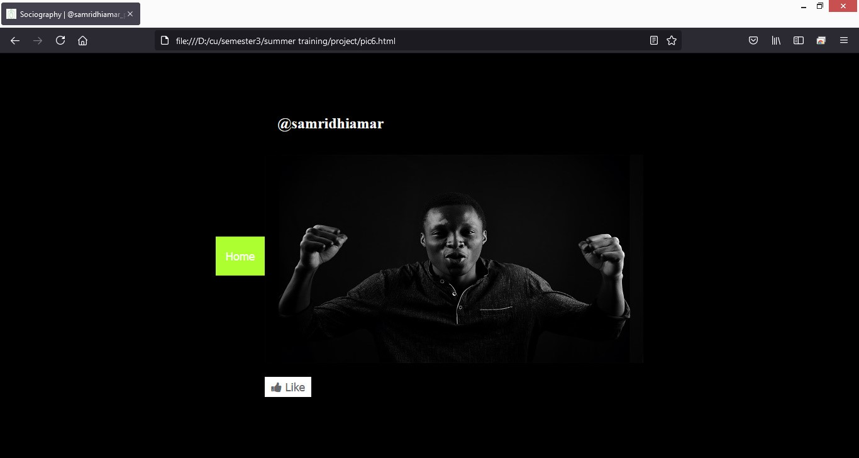

**VERIFICATION**

**5.1 Database Entries**

As the user runs the web application on a web browser, he/she is provided with a wide range of features to access. If the user is new, does sign up and logs into his/her account, all his/her entered credentials gets stored and updated into a database maintained in the back-end.

Similarly, this database stores and updates entries when accessing each feature provided to the user in the web service.

Below are some database entries which got updated after running each feature available in the web application:

**Login database**

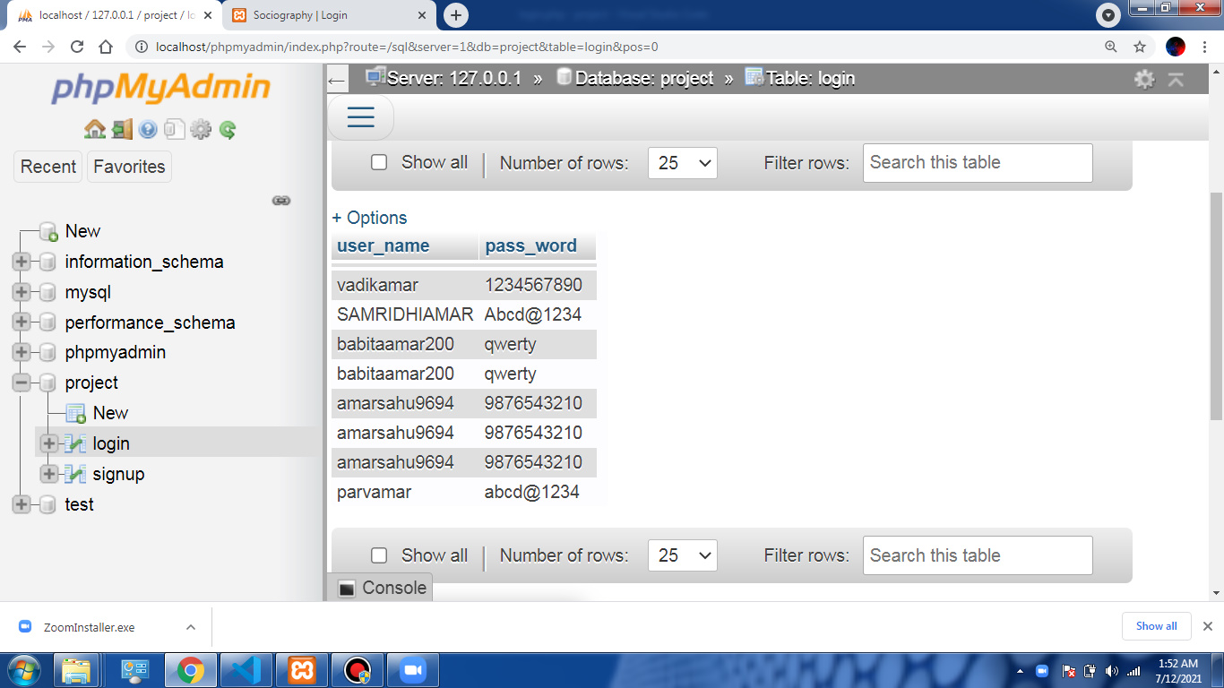

**Contact database**

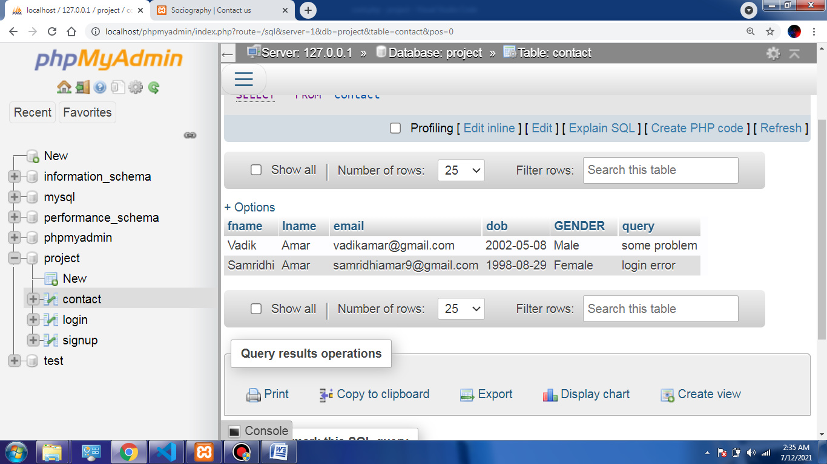

**Signup database**

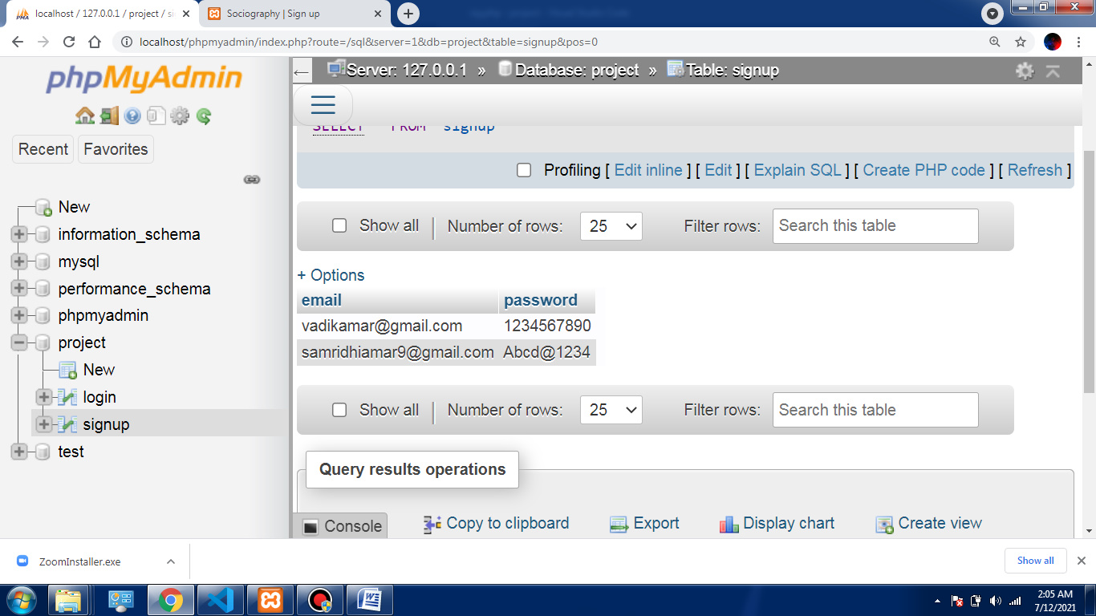

**APPLICATIONS**

**Sociography**

* People can hire photographers for their purposes.
* Top user/photographer can appear on the home page.
* Photographers can express themselves and also can keep an eye on their competitors.
* Simple design, easy to user interface.

**CONCLUSION**

* With the help of this web service, provides an interface with which the users (professionals photographs) can access, upload their best clicks and being appreciated by other photographers for their work. Others can give like to photos for appreciation. This system will also help people other than photographs to contact photographs via email address. With this web service, it will be much easier and beneficial for both the photographers and non-photographs to make contact
* There different tabs for every type of photography like wildlife, architectural etc. to make it easy for users to find pictures according their preferences. With the help of this web service, in future I am looking to add rating system which will make it more easy for the user to contact to best photographer if they need.
* We checked all the modules in different web browsers and we got exactly the outcome from the web service we expected. We ran various existing and new user accounts on our web application, and all the processes went efficiently without a single error.
* We even checked the database connectivity and performance from the back-end using IntelliJ and MySQL Workbench. We found that all the changes being made during runtime by the user using the various module features of the web application in a specific web browser is getting stored and updated in the MySQL database side by side.

**BIBLIOGRAPHY/ REFERENCES**

**Wikipedia**: - https://www.wikipedia.org/

For paragraph on photography, xampp, vs code

**W3School**: - https://www.w3schools.com/

For html, css and js

**YouTube** :- https://www.youtube.com/

For methods to install softwares

**Stackoverflow**: - https://stackoverflow.com/

For queries